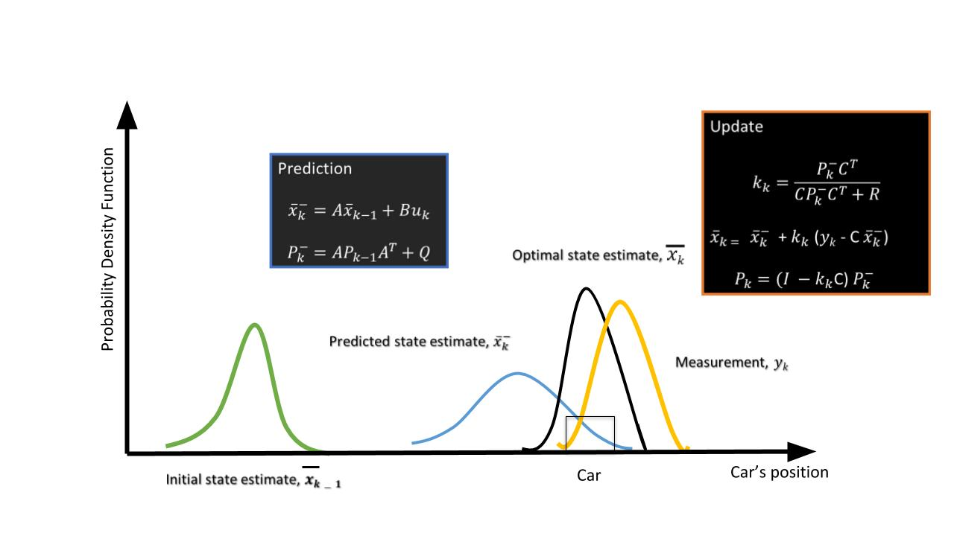

*x*^*k*​, the state of the vehicle at the *k_*th step.

*A*, the state-transition model

*Pk*​, the state covariance matrix - state estimation covariance error

*B*, control matrix - external influence

*C*, the observation/measurement model

*Q*, the covariance of the process noise

*R*, the covariance of the observation noise

The purpose of the Kalman filter is to estimate the *state* of a tracked vehicle. Here, "state" could include the position, velocity, acceleration or other properties of the vehicle being tracked. The Kalman filter uses measurements that are observed over time that contain noise or random variations and other inaccuracies, and produces values that tend to be closer to the true values of the measurements and their associated calculated values. It is the central algorithm to the majority of all modern radar tracking systems.

The Kalman filter process has two steps: prediction and update.

1. **Prediction Step**

Using the target vehicle's motion model, the next state of the target vehicle is predicted by using the current state. Since we know the current position and velocity of the target from the previous timestamp, we can predict the position of the target for next timestamp.

For example, using a constant velocity model, the new position of the target vehicle can be computed as: *xnew*​=*xprev*​+*v*∗*t*

1. **Update Step** :

Here, the Kalman filter uses noisy measurement data from sensors, and combines the data with the prediction from the previous step to produce a best-possible estimate of the state.

**Implementation in MATLAB**

The following guidelines can be used to implement a basic Kalman filter for the next project.

* You will define the Kalman filter using the trackingKF function. The function signature is as follows:
* filter = trackingKF('MotionModel', model, 'State', state, 'MeasurementModel', measurementModel, 'StateCovariance', stateCovrariance, 'MeasurementNoise', measurementNoise)

In this function signature, each property (e.g. 'MotionModel) is followed by the value for that property (e.g. model).

* For the model variable, you can pass the string '2D Constant Velocity', which will provides the 2D constant velocity motion model.
* For the 2D constant velocity model the state vector (x) can be defined as:
* [x;vx;y;vy]

Here, x and y are 2D position coordinates. The variablesvx and vy provide the velocity in 2D.

* A RadarDetectionGenerator function is used to generate detection points based on the returns after reflection. Every Radar detection generates a **detection measurement** and **measurement noise** matrix: detection.Measurement and detection.MeasurementNoise.The detection **measurement vector (z)** has the format [x;y;vx;vy].

**Measurement Models**

Measurements are what you observe about your system. Measurements depend on the state vector but are not always the same as the state vector.The measurement model assumes that the actual measurement at any time is related to the current state by

z = H*x

As a result, for the case above the **measurement model** is

H = [1 0 0 0; 0 0 1 0; 0 1 0 0; 0 0 0 1]

Using this measurement model, the state can derived from the measurements.

x = H'*z

state = H'*detection.Measurement

Further, using the generated measurement noise and measurement model define the state covariance matrix:

stateCovariance =H'*detection.MeasurementNoise*H

**Further Research**

For further explanation of Kalman Filters with MATLAB, you can refer to [this video series](https://www.youtube.com/watch?v=mwn8xhgNpFY&list=PLn8PRpmsu08pzi6EMiYnR-076Mh-q3tWr).

# MATLAB Sensor Fusion Guided Walkthrough

The following steps will take you on a guided walkthrough of performing Kalman Filtering in a simulated environment using MATLAB. You can download the starter code file Sensor_Fusion_with_Radar.m for this walkthrough in the **Resources** section for this lesson.

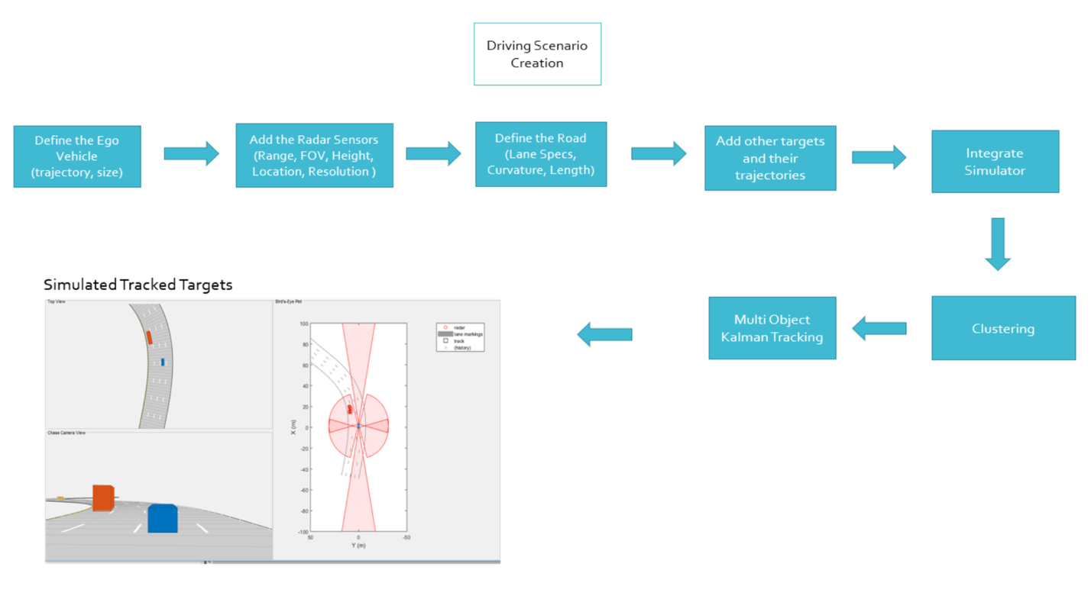

Radar Sensor Fusion Mini-Project

Sensor fusion and control algorithms for automated driving systems require rigorous testing. Vehicle-based testing is not only time consuming to set up, but also difficult to reproduce. Automated Driving System Toolbox provides functionality to define road networks, actors, vehicles, and traffic scenarios, as well as statistical models for simulating synthetic radar and camera sensor detection. This example shows how to generate a scenario, simulate sensor detections, and use sensor fusion to track simulated vehicles. The main benefit of using scenario generation and sensor simulation over sensor recording is the ability to create rare and potentially dangerous events and test the vehicle algorithms with them. This example covers the entire synthetic data workflow.

## Generate the Scenario

Scenario generation comprises generating a road network, defining vehicles that move on the roads, and moving the vehicles.In this example, you test the ability of the sensor fusion to track a vehicle that is passing on the left of the ego vehicle. The scenario simulates a highway setting, and additional vehicles are in front of and behind the ego vehicle. Find more on how to generate these scenarios here : [Automated Driving Toolbox](https://www.mathworks.com/videos/driving-scenario-designer-1529302116471.html)

*% Define an empty scenario*

scenario = drivingScenario;

scenario.SampleTime = 0.01;

*% Add a stretch of 500 meters of typical highway road with two lanes.*

*% The road is defined using a set of points, where each point defines the center of the*

*% road in 3-D space, and a road width.*

roadCenters = [0 0; 50 0; 100 0; 250 20; 500 40];

roadWidth = 7.2; *% Two lanes, each 3.6 meters*

road(scenario, roadCenters, roadWidth);

*% Create the ego vehicle and three cars around it: one that overtakes the ego vehicle*

*% and passes it on the left, one that drives right in front of the ego vehicle and*

*% one that drives right behind the ego vehicle.*

*% All the cars follow the path defined by the road waypoints by using the path driving*

*% policy. The passing car will start on the right lane, move to the left lane to pass,*

*% and return to the right lane.*

*% Create the ego vehicle that travels at 25 m/s along the road.*

egoCar = vehicle(scenario, 'ClassID', 1);

path(egoCar, roadCenters(2:**end**,:) - [0 1.8], 25); *% On right lane*

*% Add a car in front of the ego vehicle.*

leadCar = vehicle(scenario, 'ClassID', 1);

path(leadCar, [70 0; roadCenters(3:end,:)] - [0 1.8], 25); *% On right lane*

*% Add a car that travels at 35 m/s along the road and passes the ego vehicle.*

passingCar = vehicle(scenario, 'ClassID', 1);

waypoints = [0 -1.8; 50 1.8; 100 1.8; 250 21.8; 400 32.2; 500 38.2];

path(passingCar, waypoints, 35);

*% Add a car behind the ego vehicle*

chaseCar = vehicle(scenario, 'ClassID', 1);

path(chaseCar, [25 0; roadCenters(2:end,:)] - [0 1.8], 25); *% On right lane*

## Define Radar

In this example, you simulate an ego vehicle that has 6 radar sensors covering the 360 degrees field of view. The sensors have some overlap and some coverage gap. The ego vehicle is equipped with a long-range radar sensor on both the front and the back of the vehicle. Each side of the vehicle has two short-range radar sensors, each covering 90 degrees. One sensor on each side covers from the middle of the vehicle to the back. The other sensor on each side covers from the middle of the vehicle forward. The figure in the next section shows the coverage.

sensors = cell(6,1);

*% Front-facing long-range radar sensor at the center of the front bumper of the car.*

sensors{1} = radarDetectionGenerator('SensorIndex', 1, 'Height', 0.2, 'MaxRange', 174, ...

'SensorLocation', [egoCar.Wheelbase + egoCar.FrontOverhang, 0], 'FieldOfView', [20, 5]);

The rest of the radar sensors are defined in the project code.

## Create a multiObjectTracker

Create a multiObjectTracker to track the vehicles that are close to the ego vehicle. The tracker uses the initSimDemoFilter supporting function to initialize a constant velocity linear Kalman filter that works with position and velocity. Tracking is done in 2-D. Although the sensors return measurements in 3-D, the motion itself is confined to the horizontal plane, so there is no need to track the height.

tracker = multiObjectTracker('FilterInitializationFcn', @initSimDemoFilter, ...

'AssignmentThreshold', 30, 'ConfirmationParameters', [4 5]);

positionSelector = [1 0 0 0; 0 0 1 0]; *% Position selector*

velocitySelector = [0 1 0 0; 0 0 0 1]; *% Velocity selector*

MultiObjectTracker Function has several parameters that can be tuned for different driving scenarios. It controls the track creation and deletion One can learn more about these [here](https://www.mathworks.com/help/driving/ref/multiobjecttracker-system-object.html).

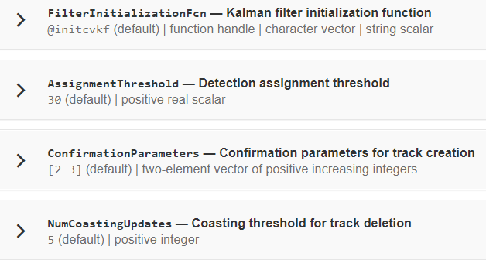

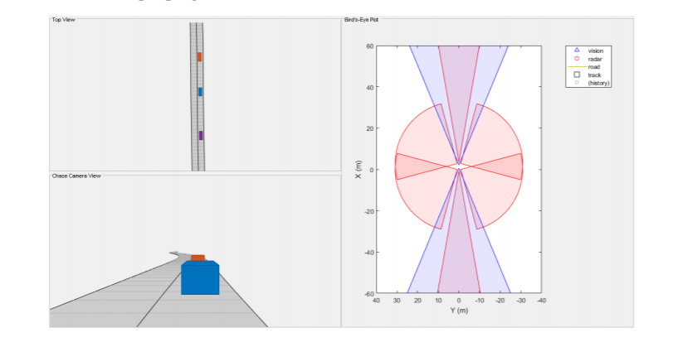

## Simulate the Scenario

The following loop moves the vehicles, calls the sensor simulation, and performs the tracking. Note that the scenario generation and sensor simulation can have different time steps. Specifying different time steps for the scenario and the sensors enables you to decouple the scenario simulation from the sensor simulation. This is useful for modeling actor motion with high accuracy independently from the sensor’s measurement rate.

Another example is when the sensors have different update rates. Suppose one sensor provides updates every 20 milliseconds and another sensor provides updates every 50 milliseconds. You can specify the scenario with an update rate of 10 milliseconds and the sensors will provide their updates at the correct time. In this example, the scenario generation has a time step of 0.01 second, while the sensors detect every 0.1 second.

The sensors return a logical flag, isValidTime, that is true if the sensors generated detections. This flag is used to call the tracker only when there are detections. Another important note is that the sensors can simulate multiple detections per target, in particular when the targets are very close to the radar sensors. Because the tracker assumes a single detection per target from each sensor, you must cluster the detections before the tracker processes them. This is done by implementing clustering algorithm, the way we discussed above.

toSnap = true;

**while** advance(scenario) && ishghandle(BEP.Parent)

*% Get the scenario time*

time = scenario.SimulationTime;

*% Get the position of the other vehicle in ego vehicle coordinates*

ta = targetPoses(egoCar);

*% Simulate the sensors*

detections = {};

isValidTime = false(1,6);

**for** i = 1:6

[sensorDets,numValidDets,isValidTime(i)] = sensors{i}(ta, time);

**if** numValidDets

detections = [detections; sensorDets]; *%#ok<AGROW>*

**end**

**end**

*% Update the tracker if there are new detections*

**if** any(isValidTime)

vehicleLength = sensors{1}.ActorProfiles.Length;

detectionClusters = clusterDetections(detections, vehicleLength);

confirmedTracks = updateTracks(tracker, detectionClusters, time);

*% Update bird's-eye plot*

updateBEP(BEP, egoCar, detections, confirmedTracks, positionSelector, velocitySelector);

**end**

*% Snap a figure for the document when the car passes the ego vehicle*

**if** ta(1).Position(1) > 0 && toSnap

toSnap = false;

snapnow

**end**

**end**

## Define the Kalman Filter

Define the Kalman Filter here to be used with multiObjectTracker.

In MATLAB a trackingKF function can be used to initiate Kalman Filter for any type of Motion Models. This includes the 1D, 2D or 3D constant velocity or even constant acceleration. You can read more about this [here](https://www.mathworks.com/help/driving/ref/trackingkf-class.html).

initSimDemoFilter This function initializes a constant velocity filter based on a detection.

**function** **filter** = **initSimDemoFilter**(detection)

*% Use a 2-D constant velocity model to initialize a trackingKF filter.*

*% The state vector is [x;vx;y;vy]*

*% The detection measurement vector is [x;y;vx;vy]*

*% As a result, the measurement model is H = [1 0 0 0; 0 0 1 0; 0 1 0 0; 0 0 0 1]*

H = [1 0 0 0; 0 0 1 0; 0 1 0 0; 0 0 0 1];

filter = trackingKF('MotionModel', '2D Constant Velocity', ...

'State', H' * detection.Measurement, ...

'MeasurementModel', H, ...

'StateCovariance', H’ * detection.MeasurementNoise * H, ...

'MeasurementNoise', detection.MeasurementNoise);

**end**

## Cluster Detections

This function merges multiple detections suspected to be of the same vehicle to a single detection. The function looks for detections that are closer than the size of a vehicle. Detections that fit this criterion are considered a cluster and are merged to a single detection at the centroid of the cluster. The measurement noises are modified to represent the possibility that each detection can be anywhere on the vehicle. Therefore, the noise should have the same size as the vehicle size. In addition, this function removes the third dimension of the measurement (the height) and reduces the measurement vector to [x;y;vx;vy].

We already went through its implementation in the clustering concept of this lesson.

## Run Your Code

Now, It’s time to run the code and see the output!

It is highly recommended to spend some time on this sensor fusion code. It’s a good place to start learning and implementing sensor fusion techniques.